PADANJALY GEOGRAPHICAL SALES PERFORMANCE REPORT

1. Executive Summary
This report presents the geographical sales performance of Padanjaly, based on the Power BI dashboard built on the cleaned order export. It covers where orders come from (countries, states and cities), how sales are distributed, and where the largest opportunities and risks lie.
Orders were placed from 269 cities across 73 states or regions in 24 countries. India is the main market, with the leading country generating ₹1.35M in sales. Within India, the business is highly concentrated in Kerala, while a small number of high-value overseas orders (Singapore, England, Georgia and Texas) add a disproportionately large share of sales. Domestic orders make up 88.3% of orders (609 of 690), while the 81 international orders (11.7%) contribute 46.5% of total order value, at an average of ₹14,488 per order against ₹2,218 for domestic orders. Almost every order (98.84%) is shipped to the same city as its billing address.
Total Cities  269 | Total States  73 | Total Countries  24 | Top Country Sales  ₹1.35M

2. Dashboard Overview
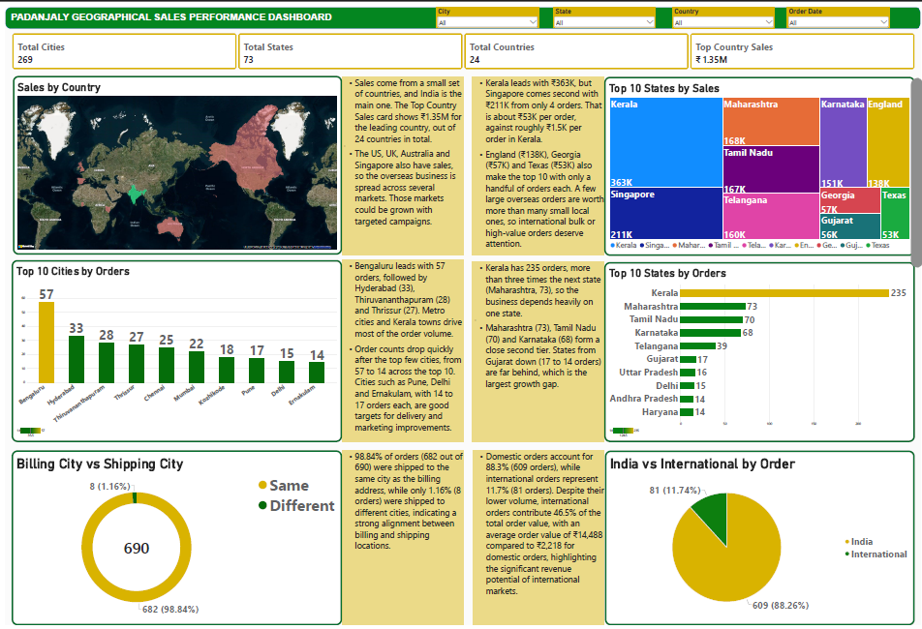

The dashboard contains four slicers (City, State, Country and Order Date), four KPI cards and six visuals, each paired with a short insight note, so management can move from headline numbers to detail on a single page.

3. KPI Definitions
All KPIs are calculated on the cleaned dataset (table: padanjaly-order export cleaned) using DAX measures.
KPI Card | Purpose | DAX Logic
Total Countries | Number of countries where orders were placed | Total Countries =  DISTINCTCOUNT(  'padanjaly-order export cleaned'[billing_country_clean]  )
Total States | Number of unique states or regions | Total States =  DISTINCTCOUNT(  'padanjaly-order export cleaned'[billing_state_clean]  )
Total Cities | Number of unique cities | Total Cities =  DISTINCTCOUNT(  'padanjaly-order export cleaned'[billing_city_clean]  )
Top Country Sales | Highest sales value among all countries | Top Country Sales =  MAXX(  VALUES(  'padanjaly-order export cleaned'[billing_country_clean]  ),  CALCULATE([Total sales])  )

4. Visual Configuration
# | Visual | Chart Type | Fields and Filters
1 | Sales by Country | Filled map | Location: billing_country; Size: Total Sales
2 | Top 10 States by Sales | Treemap | Group: billing_state_clean; Values: Total Sales; Top N filter = 10
3 | Top 10 Cities | Clustered column chart | X: billing_city; Y: Total Orders; Top N filter = 10
4 | Top 10 States | Clustered bar chart | Y: billing_state_clean; X: Total Orders; Top N filter = 10
5 | Billing City vs Shipping City | Donut chart | Legend: whether billing and shipping city are the same or different; Values: Total Orders
6 | India vs International by Order | Pie chart | Legend: India or International; Values: Total Orders

5. Business Insights
5.1 Sales by Country (Map)
- Sales come from a small set of countries, and India is the main one. The Top Country Sales card shows ₹1.35M for the leading country, out of 24 countries in total.
- The US, UK, Australia and Singapore also have sales, so the overseas business is spread across several markets. Those markets could be grown with targeted campaigns.
5.2 Top 10 States by Sales (Treemap)
- Kerala leads with ₹363K, but Singapore comes second with ₹211K from only 4 orders. That is about ₹53K per order, against roughly ₹1.5K per order in Kerala.
- England (₹138K), Georgia (₹57K) and Texas (₹53K) also make the top 10 with only a handful of orders each. A few large overseas orders are worth more than many small local ones, so international bulk or high-value orders deserve attention.
5.3 Top 10 Cities by Orders
- Bengaluru leads with 57 orders, followed by Hyderabad (33), Thiruvananthapuram (28) and Thrissur (27). Metro cities and Kerala towns drive most of the order volume.
- Order counts drop quickly after the top few cities, from 57 to 14 across the top 10. Cities such as Pune, Delhi and Ernakulam, with 14 to 17 orders each, are good targets for delivery and marketing improvements.
5.4 Top 10 States by Orders
- Kerala has 235 orders, more than three times the next state (Maharashtra, 73), so the business depends heavily on one state.
- Maharashtra (73), Tamil Nadu (70) and Karnataka (68) form a close second tier. States from Gujarat down (17 to 14 orders) are far behind, which is the largest growth gap.
5.5 Billing City vs Shipping City
- 98.84% of orders (682 of 690) were shipped to the same city as the billing address, and only 1.16% (8 orders) went to a different city.
- This close match means customers mostly order for themselves, and delivery addresses are easy to verify. The 8 differing orders are too few to matter for planning, but they are worth a quick check for gifts or address mistakes.
5.6 India vs International Orders
- Domestic orders account for 88.3% of orders (609), while international orders are 11.7% (81 orders).
- Despite the lower volume, international orders contribute 46.5% of total order value, with an average of ₹14,488 per order against ₹2,218 for domestic orders. This is about 6.5 times more per order, so international buyers are the biggest revenue opportunity.
6. Conclusion
Padanjaly has a strong home base in Kerala and a metro-driven order flow, supported by valuable but thin overseas demand. The biggest gains lie in broadening the domestic footprint beyond the top four states and converting high-value international orders into a repeatable channel. International buyers are about one order in nine but nearly half of order value, and almost all orders ship to the billing city, so shipping addresses look reliable.

